

GRAPHITE INDUSTRIES LIMITED

Website Homepage — Proposed Final Content

The website will present the company as a Tanzania-focused graphite mining, processing and value-addition enterprise, with its proposed project in Mpwapwa District, Dodoma Region. The content will be designed to engage international graphite buyers, industrial customers, technology providers, strategic partners and prospective investors.

All descriptions will distinguish between confirmed company information, proposed activities and matters still under evaluation. We will not invent mineral reserves, licences, signed buyer agreements, company leadership, financial projections or regulatory approvals

Corporate Website Narrations — Master Draft
Proposed tagline: Advancing Graphite. Creating Industrial Value.
Website: https://graphiteindustries.co.tz
Project location: Mpwapwa District, Dodoma Region, Tanzania
1. HOME PAGE

Advancing Graphite. Creating Industrial Value.
GRAPHITE INDUSTRIES LIMITED is a Tanzania-focused enterprise developing a graphite mining, processing and value-addition project in Mpwapwa District, Dodoma Region, Tanzania.
Our vision is to connect Tanzania’s mineral potential with industrial applications and market opportunities through responsible resource development, appropriate processing technologies, strategic partnerships and a strong commitment to quality.
The proposed project is being developed around the evaluation of graphite ore processing and the potential production of graphite products for domestic, regional and international markets.
We aim to establish a commercially relevant, technically sound and responsibly managed operation through systematic project evaluation, collaboration with experienced technology providers and engagement with prospective industrial customers.
Our focus: From mineral resources to processed graphite products and industrial value.

Our Strategic Priorities

Proposed Mine-to-Manufacturing Graphite Value Chain
- Run-of-Mine (ROM) Graphite Ore

From Run-of-Mine Graphite to Value-Added Manufacturing
Developing an integrated graphite processing and manufacturing platform in Mpwapwa District, Dodoma, Tanzania, serving regional and international market

The proposed value chain begins with the sourcing of run-of-mine (ROM) graphite-bearing ore from a suitable and verified mineral source. The development strategy is to establish a reliable feedstock supply supported by geological assessment, representative sampling, mineralogical characterisation and appropriate verification of mineral rights and source suitability.

Before processing requirements are finalised, the ore will need to be evaluated for graphite content, mineral associations, flake-size distribution, impurities, weathering characteristics and variability across the deposit. These factors will influence the selection of mining methods, ore handling systems and downstream processing technologies.

The objective is to establish a dependable raw-material foundation for an integrated graphite operation, with feedstock quality and consistency aligned with the requirements of the proposed processing and manufacturing facilities.

02. Crushing and Grinding

Crushing and grinding will be evaluated as the initial mechanical processing stages for preparing graphite-bearing ore for mineral separation. The objective is to reduce the ore to suitable particle sizes while liberating graphite flakes from the surrounding gangue minerals.

The proposed approach will emphasise controlled size reduction because excessive grinding can damage larger graphite flakes and reduce the potential value of products that depend on flake size. The crushing and grinding circuit will therefore need to balance liberation efficiency, preservation of valuable graphite characteristics, energy consumption and processing performance.

The final equipment configuration, grinding stages and operating parameters will be determined through ore characterisation and metallurgical testwork. This will help establish a technically appropriate and resource-efficient preparation circuit for the selected feedstock.

03. Beneficiation and Flotation

Beneficiation will be assessed as the principal mineral-separation stage for concentrating graphite and reducing the proportion of unwanted minerals in the processed material. Depending on the ore's characteristics, the proposed circuit may incorporate flotation, supported by suitable conditioning, reagent selection and separation stages.

The purpose of flotation is to exploit differences in the surface properties of graphite and associated minerals to produce a graphite concentrate suitable for further upgrading. Process development will consider concentrate grade, graphite recovery, flake preservation, reagent consumption, water requirements and the management of tailings.

The appropriate flowsheet will depend on laboratory and, where justified, pilot-scale test results. No specific concentrate grade or recovery rate should be assumed before the ore has been evaluated and the proposed process has been demonstrated to perform satisfactorily.

04. Graphite Concentrate Purification

Following beneficiation, graphite concentrate may require additional purification to meet the quality specifications of its intended industrial applications. The purification strategy will be evaluated against the required purity, residual impurity profile, flake characteristics, environmental considerations and cost of processing.

Potential approaches may include further physical separation, thermal treatment or chemical purification, subject to technical evaluation and applicable environmental and safety requirements. The suitability of each method will depend on the mineralogical composition of the concentrate and the purity specifications sought by prospective customers.

Particular attention will be given to process efficiency, energy and water consumption, reagent management, waste treatment and the potential effects of purification on the graphite's physical properties. The objective is to identify a technically viable and commercially appropriate route for producing graphite materials that meet verified customer requirements.

05. Graphite Product Manufacturing and Value Addition

The longer-term development objective is to evaluate opportunities to move beyond the sale of raw ore or unprocessed concentrate towards higher-value graphite products. The selection of downstream manufacturing activities will be guided by product specifications, technical feasibility, market demand, available technology and investment requirements.

Potential product categories for assessment include:
- Micronised graphite: Finely processed graphite for suitable industrial applications, subject to particle-size, purity and performance requirements.
- Expandable graphite: A specialised product produced through appropriate intercalation and processing methods, subject to technical validation and market assessment.
- Other processed graphite products: Additional product forms may be considered where the feedstock characteristics, manufacturing technology and customer requirements justify their development.

Product development will require appropriate laboratory testing, process design, quality-control procedures and engagement with potential industrial customers. Each product pathway will be assessed independently to establish its technical requirements and commercial suitability.

The intended strategic direction is to create opportunities for domestic processing, industrial value addition, skills development and participation in regional and international graphite supply chains, without presuming that any specific downstream product line has already been selected or commissioned.

06. Product Quality Assurance, Packaging and Export

The final stage of the proposed value chain will focus on preparing suitable graphite products for delivery to qualified industrial customers in Tanzania, the wider East African Community, the Southern African Development Community and international markets.

Product preparation may include drying, sizing, blending where appropriate, quality inspection, sampling, laboratory analysis and packaging according to the requirements of the relevant product and customer. Quality documentation may include certificates of analysis, technical data sheets, safety data sheets and other documentation required by applicable regulations or contractual specifications.

Packaging and logistics arrangements will be evaluated to protect product integrity during storage, handling and transport. Export procedures will be developed in accordance with applicable Tanzanian requirements and the import, product-compliance and documentation requirements of destination markets
Graphite Processing and Value Addition
Evaluate appropriate technologies for graphite beneficiation, product upgrading and potential downstream applications.

Industrial Partnerships
Engage qualified technology providers, engineering companies, industrial customers, research institutions and strategic investors.
Market Development
GRAPHITE INDUSTRIES LIMITED intends to assess and develop market opportunities for graphite products in Tanzania, across the East African Community (EAC), the Southern African Development Community (SADC), and selected international markets. The market development strategy will focus on identifying qualified industrial customers, understanding their technical requirements, evaluating demand for different graphite product categories and establishing commercially appropriate routes to market.
The assessment will examine potential demand for graphite concentrate, micronised graphite, expandable graphite and other processed graphite products, subject to the technical suitability of the available feedstock and the feasibility of the proposed processing and manufacturing options. Each product category will be evaluated separately because customer requirements, quality specifications, applications, pricing structures and purchasing arrangements may differ significantly.

Customer Identification and Market Assessment
The company will seek to identify potential customers across relevant industrial sectors, including manufacturers and distributors that use graphite in their production processes. Market research will consider customer locations, estimated purchasing requirements, supplier qualification procedures, product approval processes and potential opportunities for long-term supply arrangements.
Engagement with prospective buyers will help establish the specifications that products must meet before commercial supply can be considered. These may include graphite purity, fixed carbon content, particle-size distribution, flake-size characteristics, moisture levels, impurity limits, consistency between batches and packaging requirements. Actual specifications will be confirmed through customer enquiries, technical discussions and product testing.

Domestic and Regional Market Development
Within Tanzania and the wider EAC and SADC regions, the company will assess opportunities to supply suitable graphite materials to industrial users, manufacturers, processors and established mineral-trading channels. Regional market development will consider the potential benefits of proximity to customers, transport accessibility, regional trade arrangements and the possibility of supplying products in forms that meet local and regional industrial requirements.
The assessment will also consider whether selected graphite products could support greater local processing and manufacturing participation rather than relying exclusively on the export of raw materials or concentrates. Any such opportunities will be subject to verified customer demand, technical suitability and commercial feasibility.

International Markets and Export Opportunities
International market development will focus on identifying qualified buyers and distributors whose product requirements align with the graphite materials that the proposed operation could realistically produce. Potential export markets will be assessed according to customer demand, quality standards, import requirements, competition, transport costs, payment arrangements and the reliability of prospective trading relationships.
The company will evaluate opportunities to establish direct relationships with industrial end-users, specialist graphite processors, distributors and other qualified commercial partners. Where appropriate, discussions may explore sample evaluation, product qualification, trial shipments, indicative purchase requirements and longer-term supply agreements. No buyer relationship, offtake commitment or export contract will be regarded as secured until formally confirmed.

Product Quality, Pricing and Competitiveness
Market development will be closely linked to the technical evaluation of the proposed processing and manufacturing routes. The commercial attractiveness of each product will depend not only on graphite content or purity but also on the characteristics required by the intended application, consistency of supply, quality assurance and the customer's acceptance criteria.
The company will assess relevant market prices and commercial terms using credible market information, buyer enquiries and comparable products with sufficiently similar specifications. The assessment will distinguish between indicative market information and actual achievable selling prices, taking into account product quality, processing requirements, transport, packaging, insurance, duties where applicable and other costs associated with delivering products to customers.
This approach will help identify product categories and markets that warrant further technical and commercial investigation without assuming future prices, sales volumes or profitability.

Logistics, Distribution and Export Readiness
Reliable logistics will be an important consideration in selecting target markets and structuring supply arrangements. The assessment will consider road and railway connectivity, access to suitable storage and handling facilities, transport options to domestic and regional customers, and export routes through appropriate Tanzanian ports and logistics service providers.
The company will evaluate packaging, handling, warehousing, documentation and shipment arrangements according to the characteristics of each product and the requirements of its destination market. Export planning will also take account of applicable customs procedures, product documentation, customer compliance requirements and the allocation of transport and delivery responsibilities under the agreed commercial terms.

Strategic Partnerships and Market Entry
GRAPHITE INDUSTRIES LIMITED will seek to develop relationships with qualified industrial buyers, graphite processors, distributors, technology providers and other relevant commercial partners. These relationships may assist with product testing, market intelligence, customer qualification, distribution arrangements and the identification of suitable downstream manufacturing opportunities.
Market entry will be pursued progressively, beginning with market research and customer identification, followed by technical specification alignment, representative sample evaluation where available, commercial discussions and assessment of potential supply arrangements. Any commitments to supply will depend on verified feedstock suitability, demonstrated processing performance, product quality, regulatory compliance and the company's actual production readiness.

Market Development Objective
The objective is to establish a well-informed and commercially disciplined route from the proposed graphite mining and processing operation to domestic, regional and international customers. By aligning product development with verified market requirements, the company aims to evaluate opportunities for sustainable market access, increased mineral value addition in Tanzania and participation in established graphite supply chains.
Development-stage qualification: Market demand, target customers, product specifications, pricing, sales volumes and export arrangements remain subject to research, verification and commercial negotiation. This market development strategy describes intended assessment activities and does not imply that customers, purchase orders, offtake agreements or export contracts have already been secured.
Responsible Development
Integrate environmental management, occupational health and safety, community engagement, gender inclusion and sound corporate governance into project planning.

The Project
The company is evaluating a proposed graphite processing project in Mpwapwa District, Dodoma Region.
- Planned ROM ore processing capacity: 2,000 tonnes per day.
- Proposed operating schedule: 24 hours per day, three eight-hour shifts.
- Planning basis: 330 operating days per year.
- Proposed project land area: approximately 1,000 acres, subject to confirmation of land status and site requirements.
These are current planning parameters, not a statement of installed capacity, completed construction or operating production. Final project configuration will depend on technical studies, testwork, feasibility assessment, financing, approvals and implementation decisions.

Building the Right Partnerships
We welcome discussions with graphite technology providers, mineral-processing equipment suppliers, engineering companies, prospective product buyers, logistics providers, research institutions and qualified investment partners.
Our approach is to develop partnerships around clearly defined technical requirements, verifiable information and mutually agreed commercial objectives.
Call to action: Explore Our Project | Discuss a Partnership | Make a Business Enquiry

2. ABOUT US

Who We Are
GRAPHITE INDUSTRIES LIMITED is developing a graphite-focused mineral-processing facility and value-addition business in Tanzania.
The company’s proposed project in Mpwapwa District, Dodoma Region, is intended to assess opportunities for transforming graphite-bearing run-of-mine ore into upgraded products that may serve industrial markets.
Our approach combines project development, technical evaluation, processing technology assessment, market engagement and responsible business planning. We recognise that a successful graphite enterprise must align mineral characteristics, processing performance, product specifications, environmental management, logistics and customer requirements.
As the project advances, the company intends to work with suitably qualified technical and commercial partners to establish a sound basis for investment and implementation.

Our Vision
To become a recognised Tanzanian graphite processing facility and value-addition enterprise connecting mineral resources with regional and global industrial markets.
The vision for Graphite Industries Limited is to establish an integrated, mine-to-manufacturing graphite industrial facility in Mpwapwa District, Dodoma Region, Tanzania.
The concept is not limited to processing graphite ore into concentrate. It is to evaluate a complete value chain, from run-of-mine (ROM) graphite-bearing ore through beneficiation and further processing into higher-value graphite products.

Our Mission
To develop competitive graphite processing capabilities through responsible resource development, appropriate technologies, strategic partnerships, quality-focused operations and continuous improvement.

Our Core Values
- Integrity: We value honest communication, responsible conduct and reliable information.

- Technical Excellence: We support decisions based on appropriate testing, engineering and evidence.

- Responsible Development: We seek to incorporate environmental protection, worker safety and constructive community engagement into project planning.

- Partnership: We value cooperation with customers, suppliers, technical institutions, investors and other stakeholders.

- Quality and Customer Focus: We aim to understand customer specifications and develop products that can meet verified market requirements.

- Accountability: We seek clear responsibilities, sound governance and transparent decision-making throughout project development.

Our Strategic Objectives
- Advance the technical and commercial evaluation of the proposed graphite project.
- Assess graphite ore characteristics and suitable beneficiation technologies.
- Identify potential graphite products and applications through testing and market consultation.
- Establish relationships with experienced technology providers and prospective industrial customers.
- Evaluate transport, utilities, water supply and other infrastructure requirements.
- Integrate environmental, social, health and safety considerations into project planning.
- Develop the organisational capabilities and governance arrangements required for responsible project implementation

3. LEADERSHIP AND CORPORATE GOVERNANCE

Leadership
GRAPHITE INDUSTRIES LIMITED recognises that effective leadership and sound governance are essential to responsible project development.
The company’s leadership arrangements are intended to support strategic direction, risk oversight, regulatory compliance, responsible resource development and the establishment of effective business partnerships.
Official names, biographies, appointments and professional credentials of directors and senior management will be published once formally confirmed and authorised for disclosure.

Board of Directors
The Board of Directors, once its composition and appointments are confirmed for publication, will provide strategic oversight and guide the company’s long-term priorities.
Its expected responsibilities include:
- Strategic direction and corporate objectives.
- Governance, ethics and accountability.
- Oversight of material business and project risks.
- Review of project development milestones.
- Oversight of compliance and stakeholder responsibilities.
- Evaluation of major partnerships and investment decisions.

Management Team
The management team is expected to coordinate the company’s project-development activities and support implementation of approved corporate priorities.
Areas of responsibility may include project coordination, technical evaluation, commercial development, stakeholder engagement, finance, administration, environmental management and regulatory coordination, subject to the company’s final organisational structure.

Governance and Accountability
The company intends to develop governance arrangements appropriate to its activities, including clear decision-making responsibilities, financial controls, procurement procedures, risk management and compliance with applicable Tanzanian laws.
No director, executive appointment, certification or governance achievement should be represented as confirmed until supporting information has been verified.

4. OPERATIONS AND PROJECT DEVELOPMENT

The Project
GRAPHITE INDUSTRIES LIMITED is evaluating a proposed graphite mining and processing project in Mpwapwa District, Dodoma Region, Tanzania.
The project concept is intended to investigate the technical and commercial requirements for processing graphite-bearing run-of-mine ore and producing upgraded graphite products.
The current planning basis includes a proposed processing capacity of 2,000 tonnes of ROM ore per day, with an operating schedule of three eight-hour shifts per day and 330 operating days annually.
These parameters are preliminary planning assumptions. They do not establish a completed feasibility study, confirmed production rate, product recovery, saleable output or commercial operating status.

Project Development Approach

Stage 1: Mineralogical Characterisation
Representative samples will need to be characterised to understand the mineral composition, graphite occurrence, liberation characteristics and relevant impurities.
The results will inform decisions on testing requirements and potential processing routes.

Stage 2: Metallurgical Testwork
Laboratory and, where appropriate, pilot-scale testwork will be used to investigate how the ore responds to candidate beneficiation methods.
Testing should establish evidence on concentrate quality, recovery, reagent requirements, grind characteristics and other parameters relevant to process selection.

Stage 3: Process Development
Subject to test results, suitable process flowsheets and equipment configurations can be developed for further technical evaluation.
Potential unit operations may include crushing, grinding, flotation, concentrate cleaning, dewatering, drying, classification and product-quality control. The final route will depend on the ore and the required product specifications.

Stage 4: Site and Infrastructure Assessment
The project will require appropriate evaluation of land status, topography, geotechnical conditions, drainage, water availability, power supply, access roads, product handling, waste management and other site requirements.

Stage 5: Feasibility and Commercial Evaluation
Technical findings will need to be integrated with capital and operating cost estimates, environmental and social assessments, permitting requirements, logistics, market demand and financing considerations.

Stage 6: Implementation Preparation
Construction and procurement decisions should follow appropriate technical, commercial, regulatory and financing approvals.
The timing and completion of these stages will depend on the results of the project-development process.

Mining and Ore Supply
The project concept includes evaluating the supply and handling of graphite-bearing ROM ore.
The mining method, mineral rights, deposit characteristics, production schedule and ore-supply arrangements must be confirmed through the relevant company records, technical studies and regulatory documentation.
The website should not state that the company owns a graphite deposit or holds a particular mining licence until this information has been verified and approved for publication.

Infrastructure Requirements
Project planning will assess the requirements for:
- Electricity and grid connection.
- Water supply, treatment, recycling and storage.
- Access roads and transport arrangements.
- Ore receiving, stockpiling and material handling.
- Processing facilities and maintenance workshops.
- Laboratory and quality-control facilities.
- Tailings and waste management.
- Worker welfare, occupational health and safety.
- Communications, security and emergency response.
The final infrastructure configuration will be determined through site investigations and engineering studies.

5. PRODUCTS AND VALUE ADDITION

Developing Graphite Products for Industrial Markets
GRAPHITE INDUSTRIES LIMITED intends to evaluate opportunities for producing upgraded graphite products that align with verified ore characteristics and customer requirements.
The nature and quality of graphite products depend on the mineralogy of the feed material, processing performance, impurity levels, particle-size distribution and the requirements of the intended application.
The company’s product-development approach will therefore be based on testing, technical validation and engagement with prospective customers.

Potential Product Categories

Graphite Concentrate
Graphite concentrate may be produced through suitable beneficiation and cleaning processes. Its commercial suitability will depend on verified carbon content, impurities, particle-size distribution, recovery and customer specifications.

Industrial Graphite Products
Further processing and classification may enable the evaluation of graphite products for selected industrial applications. Product selection will depend on technical requirements, market demand and the economic and operational suitability of the required processes.

Advanced and Downstream Graphite Materials
The company may assess opportunities for further value addition where the feed material, technology, quality requirements and commercial case justify investigation.
Any downstream product route will require appropriate technical studies, product qualification and market validation before it is presented as an established capability.

Quality Assurance
Product quality will be a central consideration in process development and customer engagement.
The company intends to evaluate suitable sampling, laboratory testing, product specifications, quality-control procedures and independent verification arrangements as the project progresses.
Specific grades, purity levels, recovery rates and certified product specifications will be published only when supported by reliable test results.

Product Enquiries
Industrial customers and prospective buyers are invited to communicate their graphite requirements, including target specifications, particle-size distribution, intended application, annual demand and qualification procedures.
Such enquiries can help guide product evaluation and future market development.

6. MARKETS, LOGISTICS AND EXPORT DEVELOPMENT

Connecting Graphite Products with Industrial Markets
GRAPHITE INDUSTRIES LIMITED intends to assess opportunities to supply graphite products to suitable domestic, regional and international markets.
Market development will be informed by product specifications, customer qualification requirements, demand, competing supply, transport costs, trade requirements and the technical suitability of the proposed products.
The company’s objective is to develop commercially credible market relationships based on product quality, reliable information and mutually agreed terms.

Domestic and Regional Markets
The company will evaluate potential demand from industrial users, processors, manufacturers, distributors and other relevant customers in Tanzania and neighbouring markets.
Regional opportunities may include markets within the Southern African Development Community and other accessible African trade corridors, subject to product suitability, applicable trade arrangements and commercial validation.

International Markets
International market development will require an understanding of customer specifications, import requirements, product documentation, shipping arrangements, quality assurance and applicable trade regulations.
The company intends to engage prospective buyers and distributors as its product definition and technical evidence develop.
No existing export contract, confirmed buyer or committed sales volume should be stated without documentary confirmation.

Logistics and Transport
The project will assess the suitability of Tanzania’s road and railway networks for moving equipment, supplies, ore and finished products.
The potential relevance of the metre-gauge railway (MGR), standard-gauge railway (SGR) and national road network will be evaluated in relation to actual site access, available terminals, freight capacity, handling facilities, service schedules and commercial terms.
The final logistics strategy will depend on verified routes and infrastructure availability. No direct railway connection or guaranteed freight service is assumed.

Customer Engagement
Prospective customers are encouraged to share their technical requirements and procurement procedures.
Engagement may include preliminary product discussions, sample evaluation when representative material is available, specification alignment, quality verification and commercial negotiations.
Any supply commitment will be subject to appropriate approvals and a mutually agreed contract.

7. SUSTAINABILITY, ENVIRONMENT AND SOCIAL RESPONSIBILITY

Responsible Project Development
GRAPHITE INDUSTRIES LIMITED intends to incorporate environmental, social, health and safety considerations into the development of its proposed graphite project.
The company recognises that responsible mineral processing requires careful planning for water, energy, tailings, waste, emissions, biodiversity, worker welfare and relationships with surrounding communities.
The measures described on this website represent intended priorities for project development. Specific policies, management systems, permits and performance results will be communicated once formally established and verified.

Environmental Management
Project studies are expected to evaluate the potential environmental impacts of the proposed activities and identify appropriate prevention, mitigation, monitoring and management measures.
Priority areas include:
- Water sourcing, treatment, recycling and conservation.
- Tailings, waste and process-residue management.
- Dust, noise and emissions control.
- Energy efficiency and responsible resource use.
- Land disturbance, rehabilitation and closure planning.
- Biodiversity and the surrounding natural environment.
- Emergency preparedness and pollution prevention.
Environmental requirements and applicable approvals will be determined in accordance with Tanzanian law and the project’s final scope.

Occupational Health and Safety
Worker safety will be an important consideration in the design and planning of any future operations.
Relevant measures are expected to address hazard identification, safe operating procedures, machinery guarding, electrical safety, dust exposure, personal protective equipment, training, emergency response and incident reporting.
Detailed safety procedures will need to be developed before operations commence and adapted to the final process and site conditions.

Community Engagement
Constructive engagement with relevant local communities and stakeholders is important to understanding local priorities, managing potential impacts and building accountable relationships.
The company intends to consider appropriate engagement mechanisms, information sharing, grievance handling, local participation and coordination with relevant authorities.
Any commitments concerning community programmes, employment numbers or local procurement targets will be published only when formally approved.

Gender Inclusion and Local Skills
The company supports the objective of fair opportunity and professional development in the mining and mineral-processing sector.
As the organisation and project develop, consideration will be given to fair recruitment, technical training, women's participation, workplace dignity, equal opportunity and the development of local skills and suppliers.
Specific targets will be established only when approved and supported by a practical implementation plan.

Governance and Business Ethics
Responsible development also requires integrity in business relationships, procurement, employment, financial management and regulatory engagement.
The company intends to establish appropriate standards for ethical conduct, compliance, risk management, accountability and the prevention of bribery and corruption

8. PARTNERSHIPS AND TECHNOLOGY

Building Partnerships for Graphite Development
GRAPHITE INDUSTRIES LIMITED welcomes engagement with qualified organisations that can contribute to the technical, commercial and responsible development of the proposed graphite project.
The company recognises that successful project development may require cooperation across mineral characterisation, metallurgical testing, engineering, equipment supply, environmental assessment, product development, logistics, market access and financing.

Technology Providers and Engineering Companies
The company is interested in evaluating suitable technologies and engineering services for graphite processing.
Potential areas of cooperation include:
- Mineralogical characterisation.
- Metallurgical and beneficiation testwork.
- Process flowsheet development.
- Preliminary and detailed engineering.
- Equipment selection and process optimisation.
- Water, tailings and environmental management.
- Laboratory systems and product-quality control.
- Plant commissioning and operational training, where applicable.
Technology selection will depend on test results, performance requirements, technical suitability, lifecycle considerations and commercial terms.

Equipment Suppliers
Equipment suppliers may engage with the company to understand project requirements and propose appropriate solutions.
Technical proposals should clearly distinguish equipment supply, engineering services, installation, commissioning, training, warranties and other contractual responsibilities.
No equipment order or supplier appointment should be implied unless confirmed.

Research and Technical Institutions
The company welcomes appropriate technical dialogue with universities, laboratories, research institutions and specialist consultants.
Potential cooperation may include graphite characterisation, process development, testing methods, product applications, environmental studies and workforce skills development.

Strategic and Investment Partnerships
The company is open to discussions with suitably qualified strategic partners and prospective investors interested in graphite processing and value addition in Tanzania.
Any proposed investment or partnership will be subject to due diligence, technical and commercial evaluation, applicable approvals and mutually agreed contractual arrangements.

9. STRATEGIC BUYERS AND INDUSTRIAL CUSTOMERS

Engage with Our Project
GRAPHITE INDUSTRIES LIMITED seeks to understand the requirements of prospective industrial customers as it evaluates graphite processing and product-development opportunities.
Early engagement can help establish the product characteristics, testing requirements, quality standards and commercial conditions that future customers may require.

Who May Engage With Us?
We welcome enquiries from:
- Industrial graphite consumers.
- Graphite processors and product manufacturers.
- Distributors and commodity traders.
- Industrial material suppliers.
- Product-development and technology companies.
- Regional and international buyers.
These categories identify potential audiences for engagement; they do not imply existing customer relationships.

Information We Welcome
Prospective customers may provide:
- Intended graphite application.
- Required carbon content and impurity limits.
- Particle-size distribution.
- Required physical or chemical properties.
- Estimated demand and delivery schedule.
- Packaging and shipping requirements.
- Sample testing and supplier-qualification procedures.
- Applicable documentation and quality standards.
The information will help guide product evaluation and customer discussions.

Commercial Engagement Process
Depending on project readiness and the availability of representative material, engagement may progress through initial enquiry, technical requirement review, sample evaluation, specification alignment, commercial discussion and contractual due diligence.
Samples, quotations, supply schedules and commercial commitments will be offered only when the necessary information and approvals are available.
Call to action: Submit a Product Enquiry | Discuss Technical Requirements

10. PROJECT LOCATION

Mpwapwa District, Dodoma Region, Tanzania
The proposed graphite processing project is being evaluated in Mpwapwa District, Dodoma Region, Tanzania.
The location provides the basis for assessing access to transport infrastructure, electricity, water, labour, suppliers and potential domestic and export markets.
Detailed site investigations will be required to establish the suitability of the land, ground conditions, drainage, water availability, grid connection, road access, environmental constraints and other infrastructure requirements.
The potential use of national road and railway corridors will be evaluated against actual routes, terminal access, freight availability and commercial conditions.
The current planning concept refers to a proposed project land area of approximately 1,000 acres. The legal status, boundaries, permitted use and suitability of the land must be confirmed before any claim of ownership, secure tenure or development rights is published.
The location page will be updated as verified technical and site information becomes available.

11. CONTACT US

Start a Conversation
GRAPHITE INDUSTRIES LIMITED welcomes enquiries from prospective industrial customers, technology providers, engineering companies, equipment suppliers, research institutions, logistics providers and qualified strategic partners.
Whether your interest concerns graphite processing technology, product specifications, project development or potential commercial cooperation, we welcome a clear description of your organisation and proposed area of engagement.

General Enquiries
Please use the company’s verified official contact details once confirmed.
Company: GRAPHITE INDUSTRIES LIMITED
Website: https://graphiteindustries.co.tz
Project location: Mpwapwa District, Dodoma Region, Tanzania
E-mail: ce@graphiteindustries.co.tz
Telephone: +255 713 283 711 / + 255 725 283 712
Registered Head Office: 8th Floor, Morocco Squire, Mwai Kibaki Road, Kinondoni District, Dar es Salaam, Tanzania
Google Map: https://maps.app.goo.gl/bGjHb68xQnGH4SKW8

Enquiry Form Fields
- Full name.
- Organisation.
- Business email.
- Telephone number, optional.
- Country.
- Enquiry category.
- Subject.
- Message.
- Consent to the applicable privacy notice.

Enquiry Categories
- Graphite product enquiry.
- Technology and engineering.
- Equipment supply.
- Strategic partnership.
- Investment enquiry.
- Logistics and market development.
- Research and technical cooperation.
- General enquiry.
All contact details must be verified before publication. The website form must be connected to a functioning, secure submission service before launch.
12. DOWNLOADABLE CORPORATE PROJECT BRIEF

GRAPHITE INDUSTRIES LIMITED — Corporate Project Overview
GRAPHITE INDUSTRIES LIMITED is developing a proposed graphite mining, processing and value-addition project in Mpwapwa District, Dodoma Region, Tanzania.
The project concept is focused on evaluating the technical and commercial requirements for processing graphite-bearing ROM ore and developing products for potential domestic, regional and international markets.

Current Planning Basis
- Proposed location: Mpwapwa District, Dodoma Region, Tanzania.
- Planned ROM ore processing capacity: 2,000 tonnes per day.
- Proposed operating schedule: three eight-hour shifts daily.
- Planning assumption: 330 operating days annually.
- Proposed land area: approximately 1,000 acres, with land status requiring confirmation.
These parameters describe the current planning concept and should not be interpreted as verified reserves, installed capacity, proven output or an operational facility.

Development Priorities
The project-development programme is expected to address mineralogical characterisation, metallurgical testwork, process technology evaluation, preliminary engineering, site and infrastructure studies, environmental and social assessment, market development and commercial feasibility.

Potential Cooperation Areas
The company welcomes appropriate engagement with:
- Graphite processing technology providers.
- Mineral-processing equipment manufacturers.
- Engineering and technical service providers.
- Laboratories and research institutions.
- Prospective industrial customers and product buyers.
- Logistics and distribution providers.
- Qualified strategic and investment partners.

Project Status
The project remains subject to further technical, commercial, environmental, regulatory and financing work.
The final configuration, product portfolio, implementation schedule and commercial arrangements will depend on the results of this work and the necessary approvals.
Head Office Contacts
8th Floor, Morocco Squire, Mwai Kibaki Road, Kinondoni District, Dar es Salaam, Tanzania
Google Map Location: https://maps.app.goo.gl/bGjHb68xQnGH4SKW8
Tanzania's Graphite Value Chain

Advancing Graphite. Creating Industrial Value.
Developing graphite processing and value-addition opportunities to connect Tanzania's mineral resources with industrial markets.
Explore Our Project →
Discover the company
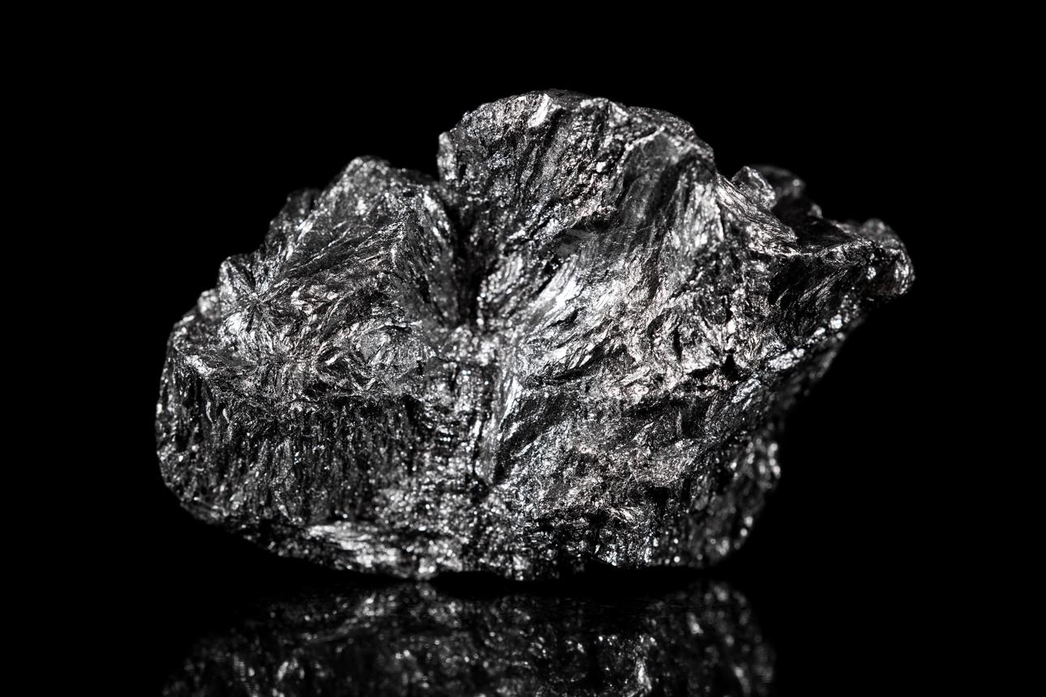

who we are

Building a Graphite Processing Platform in Tanzania
GRAPHITE INDUSTRIES LIMITED is focused on developing opportunities in graphite beneficiation, mineral value addition and downstream industrial materials, with a proposed processing project in Mpwapwa District, Dodoma Region.
NTEGRATED GRAPHITE PROCESSING & MANUFACTURING
From Run-of-Mine Graphite to Value-Added Manufacturing
Developing an integrated graphite processing and manufacturing platform in Mpwapwa District, Dodoma, Tanzania, serving regional and international markets.
Mineral Processing
Value Addition
Global Markets
This is our proposed visual direction for the website, not a claim that the facility is already operational
Phase 1 — Corporate identity and positioning
Establish the company profile, vision, mission, strategic objectives and professional brand identity.
Phase 2 — Projects and products
Present the proposed integrated graphite beneficiation facility and potential value-added graphite product lines without inventing specifications or production capacity.
Phase 3 — Markets and partnerships
Position the company for industrial customers, regional trade, international buyers, technology providers, investors and strategic partners.
Phase 4 — Website construction
Develop the homepage, About Us, Operations, Products, Sustainability, Partnerships, Contact Us and downloadable corporate project brief.
Phase 5 — Launch preparation
Domain, hosting, mobile responsiveness, enquiry forms, search visibility and publication.
02. About Us
Company profile, vision, mission, leadership and strategic objectives.

03. Operations and Projects
The proposed graphite processing project in Mpwapwa District, Dodoma, Tanzania, including development plans and processing technology
04. Products and Value Addition
Planned graphite concentrates, industrial graphite products and potential downstream applications, subject to project development and product specifications.
05. Sustainability and Partnerships
Responsible mining, environmental management, local employment, technology partnerships and investment opportunities.
06. Contact Us
Corporate contacts, location, partnership enquiries and business communications.
Company overview
GRAPHITE INDUSTRIES LIMITED is a Tanzania-focused industrial enterprise being positioned to participate in the graphite value chain through mineral processing, value addition and the development of graphite-based industrial products.
The company's strategic direction is to develop opportunities that connect Tanzania's mineral resources with domestic, regional and international markets. Through appropriate processing technology, technical partnerships and responsible project development, the company aims to contribute to the growth of Tanzania's mineral beneficiation and downstream manufacturing sectors.
A key development priority is the proposed graphite processing project in Mpwapwa District, Dodoma Region, Tanzania. The project is being approached with a focus on technical evaluation, process design, infrastructure planning and the identification of appropriate markets for graphite products.
The company's long-term ambition is to establish a commercially viable platform for graphite processing and value addition, subject to feasibility assessments, financing, permitting and implementation.
Vision
- To become a recognised Tanzanian enterprise in graphite processing and value addition, connecting mineral resources with industrial markets and contributing to sustainable economic development.

- To establish a competitive Tanzanian graphite value-addition and advanced materials business, connecting responsibly sourced mineral feedstock with diversified industrial and international markets.

- The vision for Graphite Industries Limited is to establish an integrated, mine-to-manufacturing graphite industrial facility in Mpwapwa District, Dodoma Region, Tanzania whereas supporting Tanzanian industry and reducing reliance on imports.

- The concept is not limited to processing graphite ore into concentrate. It is to evaluate a complete value chain, from run-of-mine (ROM) graphite-bearing ore through beneficiation and further processing into higher-value graphite products
Our Mission
- To develop competitive graphite processing and value-addition capabilities through sound technical planning, responsible resource development, strategic partnerships and a strong commitment to quality, safety and environmental responsibility.

- To develop an integrated, technically sound and commercially viable graphite processing and manufacturing operation through responsible feedstock evaluation, appropriate technology, product diversification, strategic partnerships and disciplined investment

Strategic objectives
- Develop the proposed graphite processing project through systematic technical and commercial evaluation.
- Identify suitable processing technologies and optimise graphite recovery, product quality and operational efficiency.
- Progress opportunities for value addition and downstream graphite manufacturing as supported by feasibility studies and market demand.
- Establish relationships with technology providers, equipment manufacturers, investors, industrial customers and international buyers.
- Support local employment, skills development and Tanzanian participation in the mineral value chain.
- Integrate environmental management, occupational health and safety, and responsible resource utilisation into project planning.
Core business areas
Graphite mineral processing
Development of processing capabilities to beneficiate graphite-bearing ore into marketable products, with flowsheet design and operating parameters determined through metallurgical testing.
Graphite product development
Evaluation of graphite concentrate grades, particle-size specifications and other product characteristics required by target customers.
Downstream value addition
Assessment of opportunities for further processing and graphite-based industrial materials, subject to technical suitability and commercial viability
Technology and investment partnerships
Collaboration with engineering companies, research institutions, equipment suppliers, investors and prospective offtake partners.
Project development
The proposed graphite processing project in Mpwapwa District is a central component of the company's development programme. The current planning work includes consideration of a nominal 2,000 tonnes per day (TPD) processing concept, subject to confirmation through feasibility and engineering studies.
The development programme is expected to address:
- Ore characterisation and mineralogical analysis.
- Metallurgical testing and flowsheet development.
- Preliminary engineering and equipment selection.
- Power, water, transport and site infrastructure requirements.
- Environmental and social assessment and applicable regulatory approvals.
- Capital requirements, operating costs, product specifications and market evaluation.
The final plant design, recoveries, production volumes, product grades and project economics will be established through appropriate technical and commercial studies.
GRAPHITE Industries Limited
The website should communicate a modern industrial identity, technical credibility and an investment-ready development approach without implying that construction, mining or production has already begun.
Recommended sitemap
Home
Project positioning, vision, strategic value proposition and partnership call to action.
About Us
Company profile, mission, values, governance and responsible development principles.
Mine-to-Manufacturing Strategy and Corporate Website Concept
Proposed project location: Mpwapwa District, Dodoma Region, Tanzania · Development and investor engagement stage
GRAPHITE Industries Ltd. is being positioned as a proposed integrated graphite beneficiation and value-added manufacturing business in Tanzania. Its strategic objective is to evaluate suitable graphite feedstock, establish an appropriate beneficiation process and progressively develop multiple graphite products for domestic, regional and international markets.
The strategy must remain evidence-led. Feedstock sources, mineral resources, processing capacity, product yields, capital costs and project economics have not been established in the information provided. These will be determined through technical studies, commercial validation and feasibility work
- Strategic objectives
- Evaluate and secure a technically suitable, commercially reliable feedstock supply.
- Establish a beneficiation process supported by representative sampling and metallurgical testwork.
- Prioritise graphite products according to market demand, achievable specifications and manufacturing complexity.
- Develop infrastructure and logistics arrangements suited to the confirmed plant site.
- Attract investors, technology providers, engineering partners and product offtakers.
- Expand progressively into higher-value manufacturing as technical capability and market qualification permit.

Mine-to-manufacturing business model

The recommended model is an integrated, phased value chain. Integration does not require GRAPHITE Industries Ltd. to own a graphite mine from the outset. It can evaluate third-party feedstock, develop supply agreements and consider mining participation only if supported by geological, legal and commercial due diligence.

Product prioritisation strategy
GRAPHITE Industries Ltd. should develop its product portfolio in stages rather than attempting to manufacture every graphite product at initial commissioning.
Priority 1
Graphite concentrate
Foundation product
Establish the achievable concentrate grade, flake-size distribution, impurity profile, recovery and customer acceptance. Use these results to inform plant design and initial offtake discussions
Priority 2
Micronised and classified graphite
First value-addition candidates
Evaluate particle-size reduction and classification for qualified industrial customers. Determine whether the additional processing cost is justified by customer specifications and achievable selling terms.
Priority 3
Expandable graphite
Assess whether the feedstock's flake characteristics and chemistry are suitable. The product requires a dedicated process, quality control, appropriate chemical handling and confirmed buyers.
These are indicative development priorities, not a forecast of profitability. The final ranking must follow feedstock testwork, market enquiries, product trials, process costs and investment requirements.
Product-market validation
For every proposed product, the project team should establish:
- Target customer and application.
- Required carbon content and impurity limits.
- Particle-size or flake-size specification.
- Sample and qualification requirements.
- Packaging and transport requirements.
- Indicative pricing and payment terms, where available.
- Expected product yield and processing cost from the tested feedstock.
- Evidence of demand, including written expressions of interest or offtake discussions.
4. Phased development and decision gates
The project should advance through defined technical and commercial gates. No plant capacity or construction schedule should be fixed before the required studies are complete.
01
Feedstock and market screening
Establish a shortlist of potential suppliers or deposits, collect representative samples, conduct preliminary mineralogical and chemical analysis, interview prospective customers, and screen the Mpwapwa site and its infrastructure.
Gate: viable feedstock candidates and credible product-market opportunities identified.
02
Metallurgical testwork and product development
Complete laboratory tests, establish the preliminary process flowsheet, assess recovery and flake preservation, produce representative concentrate and value-added samples, and obtain feedback from potential buyers.
Gate: technically credible process route and products that can meet target specifications.

03 Pre-feasibility and project definition
Compare plant configurations, determine preliminary capacity options from verified feedstock availability and market demand, assess utilities and logistics, and prepare preliminary capital and operating cost estimates.
Gate: preferred development option with transparent risks and a credible commercial rationale.
04 Feasibility, approvals and financing
Advance engineering, environmental and social assessments, permitting, commercial agreements, project financing and risk allocation to the level required by prospective investors and lenders.
Gate: investment decision supported by sufficiently reliable technical, legal, market and financial evidence.
05 Construction, commissioning and operational validation
Subject to financing and approvals, procure equipment, construct and commission the selected facility, verify performance and product quality, and establish operating controls.
Gate: demonstrated operating performance and products accepted against agreed specifications.
06 Expansion into multiple products
Add downstream processing in response to proven demand, reliable feedstock quality, demonstrated plant performance and a separate investment case for each additional product line.
5. Required technical and commercial studies
Study | Main purpose and deliverable
Feedstock and geological assessment | Verify source identity, ownership or supply rights, available geological evidence, sample representativeness and potential continuity of supply.
Mineralogy and assay programme | Determine graphitic carbon, impurities, mineral associations, flake characteristics and variability.
Metallurgical testwork | Evaluate crushing, grinding, flotation, cleaning, recovery, concentrate grade, flake preservation, water requirements and process residues.
Pilot testing, if warranted | Validate process performance and generate sufficient representative product for customer testing and engineering design.
Product development | Confirm product specifications, finishing processes, quality controls, packaging and potential applications.
Market and offtake study | Assess competing suppliers, demand, customer qualification, pricing basis, logistics and potential purchase commitments.
Site and infrastructure study | Verify land suitability, access roads, electricity, water, communications, drainage, waste management and logistics alternatives.
Environmental and social assessment | Determine applicable approvals and assess impacts, mitigation, occupational safety, community engagement and rehabilitation requirements.
Engineering and plant design | Develop the process flowsheet, mass and water balances, equipment selection, layout, utilities, construction requirements and capital estimate.
Transport and logistics study | Compare road and rail options, terminal access, freight rates, handling, packaging, port procedures and export routes.
Financial feasibility | Develop evidence-based capital and operating cost estimates, cash-flow forecasts, financing scenarios, sensitivity analysis and investment returns.
Legal and regulatory review | Confirm company and land arrangements, mineral and processing permissions, environmental approvals, tax and fiscal obligations, local-content requirements and export compliance.
The studies should be commissioned in sequence, with the scope of later work determined by the evidence produced earlier. This avoids committing substantial engineering expenditure before the feedstock and process route are understood.
- Infrastructure strategy: Mpwapwa – Gulwe Railway Station
Site utilities: verify electricity supply, water availability,
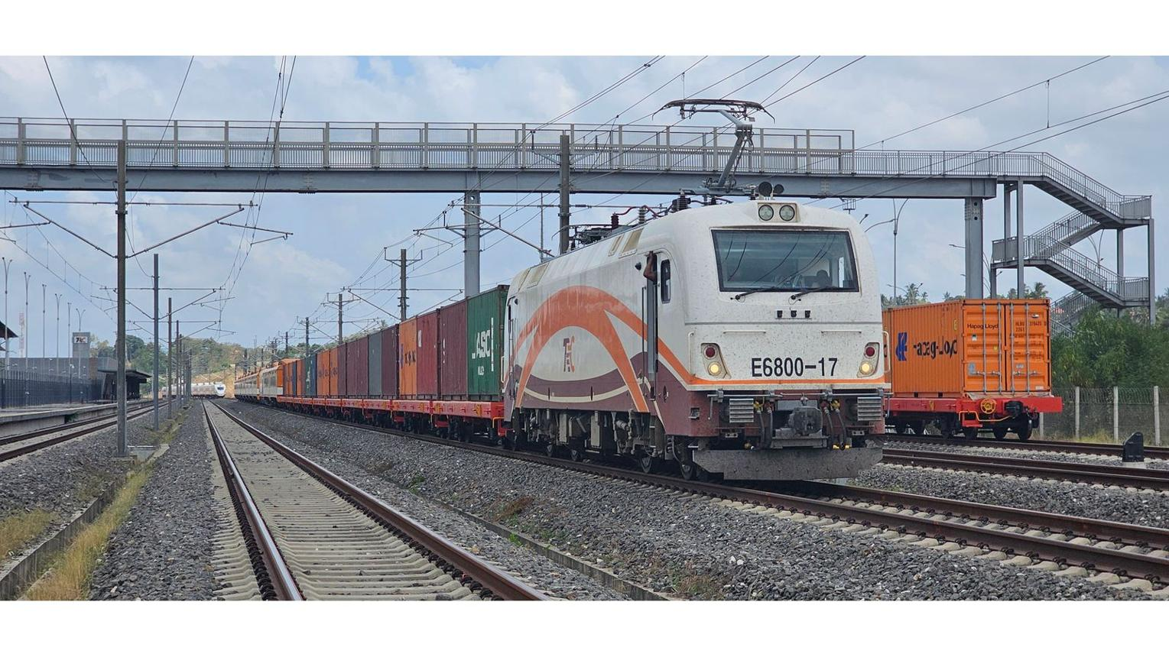
National Central Road Network Corridor
Central road network: assess road connections for feedstock delivery, machinery transport, finished-product distribution and access to commercial centres.
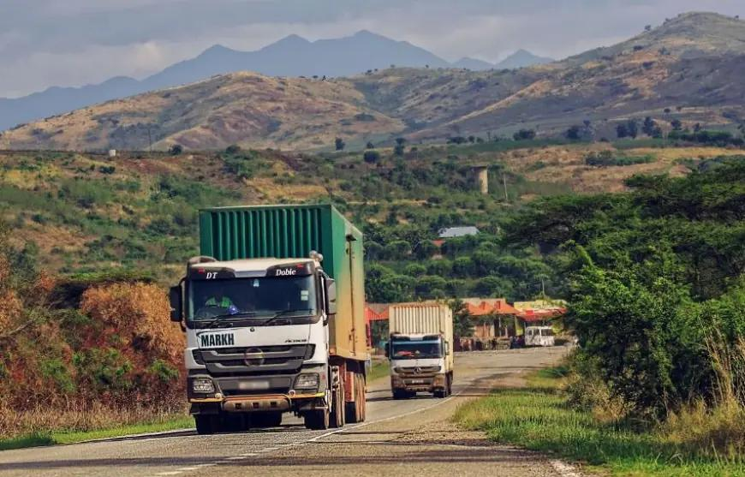
Dar Es Salaam Port Shipping Facility
Dar es Salaam Port and associated logistics facilities: assess export handling, storage, container availability and total delivered cost.
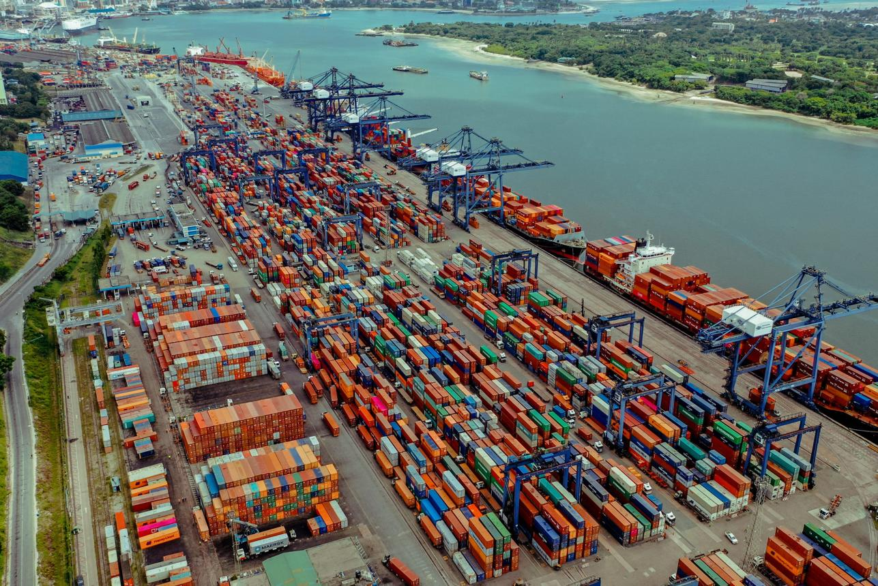
The proposed facility should assess connectivity with:
- SGR — Standard Gauge Railway: investigate available freight services and the practical route to a suitable terminal.
- MGR — Metre Gauge Railway: compare existing railway freight options where service, loading facilities and rates are suitable.
- telecommunications and the requirements for industrial operations.
- Site utilities: verify electricity supply, water availability,
Tanzania has announced SGR freight services between Dar es Salaam and Dodoma, including the Kwala logistics hub, creating a potential basis for evaluating rail-integrated logistics. However, the project's actual rail access and commercial suitability must be established through a site-specific transport study.
The infrastructure study should compare delivered feedstock cost and delivered product cost under different transport arrangements. It should not assume that a railway line or freight terminal provides direct access to the plant.
Investor positioning and partnership strategy
Investment proposition
GRAPHITE Industries Ltd. should be presented as a proposed, phased graphite processing and manufacturing opportunity, not as an established mine or operating factory.
The investment case should be built around five propositions:
- Mineral value addition in Tanzania: evaluating opportunities to transform suitable graphite feedstock into higher-value products.
- Flexible feedstock strategy: assessing external supply, mining partnerships and other commercially viable arrangements before selecting a definitive model.
- Product diversification: developing an initial concentrate business and evaluating additional product lines as customer demand and process performance are established.
- Infrastructure-led planning: evaluating the Central National road network Corridor, MGR, SGR and port logistics to optimise transport and market access.
- Disciplined, staged investment: advancing capital commitments only after the relevant technical, environmental, commercial and financing decision gates are satisfied.
Target strategic partners
Partner category | Proposed role
Equity investors | Fund agreed development stages and potential plant construction.
Technical and process-technology partners | Provide testwork, process design, equipment selection and commissioning support.
Feedstock suppliers and mining companies | Provide samples, technical data and potential supply agreements.
Engineering, procurement and construction firms | Develop engineering designs, cost estimates and construction proposals.
Product buyers and offtakers | Validate specifications, test samples and negotiate potential purchase commitments.
Development finance institutions and lenders | Consider financing once the project reaches the relevant diligence and bankability thresholds.
Logistics and infrastructure providers | Assess transport, freight handling, warehousing and export arrangements.
. Required technical and commercial studies
Study | Main purpose and deliverable
Feedstock and geological assessment | Verify source identity, ownership or supply rights, available geological evidence, sample representativeness and potential continuity of supply.
Mineralogy and assay programme | Determine graphitic carbon, impurities, mineral associations, flake characteristics and variability.
Metallurgical testwork | Evaluate crushing, grinding, flotation, cleaning, recovery, concentrate grade, flake preservation, water requirements and process residues.
Pilot testing, if warranted | Validate process performance and generate sufficient representative product for customer testing and engineering design.
Product development | Confirm product specifications, finishing processes, quality controls, packaging and potential applications.
Market and offtake study | Assess competing suppliers, demand, customer qualification, pricing basis, logistics and potential purchase commitments.
Site and infrastructure study | Verify land suitability, access roads, electricity, water, communications, drainage, waste management and logistics alternatives.
Environmental and social assessment | Determine applicable approvals and assess impacts, mitigation, occupational safety, community engagement and rehabilitation requirements.
Engineering and plant design | Develop the process flowsheet, mass and water balances, equipment selection, layout, utilities, construction requirements and capital estimate.
Transport and logistics study | Compare road and rail options, terminal access, freight rates, handling, packaging, port procedures and export routes.
Financial feasibility | Develop evidence-based capital and operating cost estimates, cash-flow forecasts, financing scenarios, sensitivity analysis and investment returns.
Legal and regulatory review | Confirm company and land arrangements, mineral and processing permissions, environmental approvals, tax and fiscal obligations, local-content requirements and export compliance.
The studies should be commissioned in sequence, with the scope of later work determined by the evidence produced earlier. This avoids committing substantial engineering expenditure before the feedstock and process route are understood.

Investor information package
Before approaching investors for a firm financing commitment, prepare a controlled data room containing, as available:
- Company incorporation and ownership documentation.
- Project site and land-status documentation.
- Feedstock-source assessment and supporting evidence.
- Laboratory assays and metallurgical testwork.
- Preliminary process flowsheet and plant design basis.
- Market study and product-sample results.
- Infrastructure and logistics assessment.
- Environmental and social study status.
- Preliminary capital and operating cost estimates, when technically supported.
- Financial model, sensitivity analysis and financing structure, once credible cost and production inputs are available.
- Risk register, development programme and approvals schedule.
The vision for Graphite Industries Limited is to establish an integrated, mine-to-manufacturing graphite industrial facility in Mpwapwa District, Dodoma Region, Tanzania whereas supporting Tanzanian industry and reducing reliance on imports.
The concept is not limited to processing graphite ore into concentrate. It is to evaluate a complete value chain, from run-of-mine (ROM) graphite-bearing ore through beneficiation and further processing into higher-value graphite products.

Graphite Industries Limited
Proposed integrated graphite processing and manufacturing facility | Mpwapwa, Tanzania

1. Proposed mine-to-manufacturing value chain

01 Run-of-Mine Graphite Ore
Graphite-bearing ore supplied from a suitable, verified mineral source.

02 Crushing and Grinding
Liberate graphite flakes while managing particle-size reduction.

03 Beneficiation and Flotation
Separate graphite from gangue minerals and improve concentrate grade.

04 Concentrate Purification
Evaluate physical or chemical purification methods against product specifications.

05 Graphite Product Manufacturing
Assess opportunities for expandable graphite, micronised graphite, and other suitable downstream products.

06 Packaging and Export
Produce, test, certify, package, and supply products to qualified industrial customers.
This is a proposed value chain, not a confirmed plant design. The final configuration will depend on ore mineralogy, flake-size distribution, liberation characteristics, recovery testwork, energy and water requirements, market demand, and financial feasibility.

Manufacturing products to evaluate

9. Corporate website concept and proposed copy
The website should serve as the project's principal corporate presentation to investors and industrial partners.
Home
Present the company's vision, the Mpwapwa project, integrated value chain, development status, and investment enquiry link.
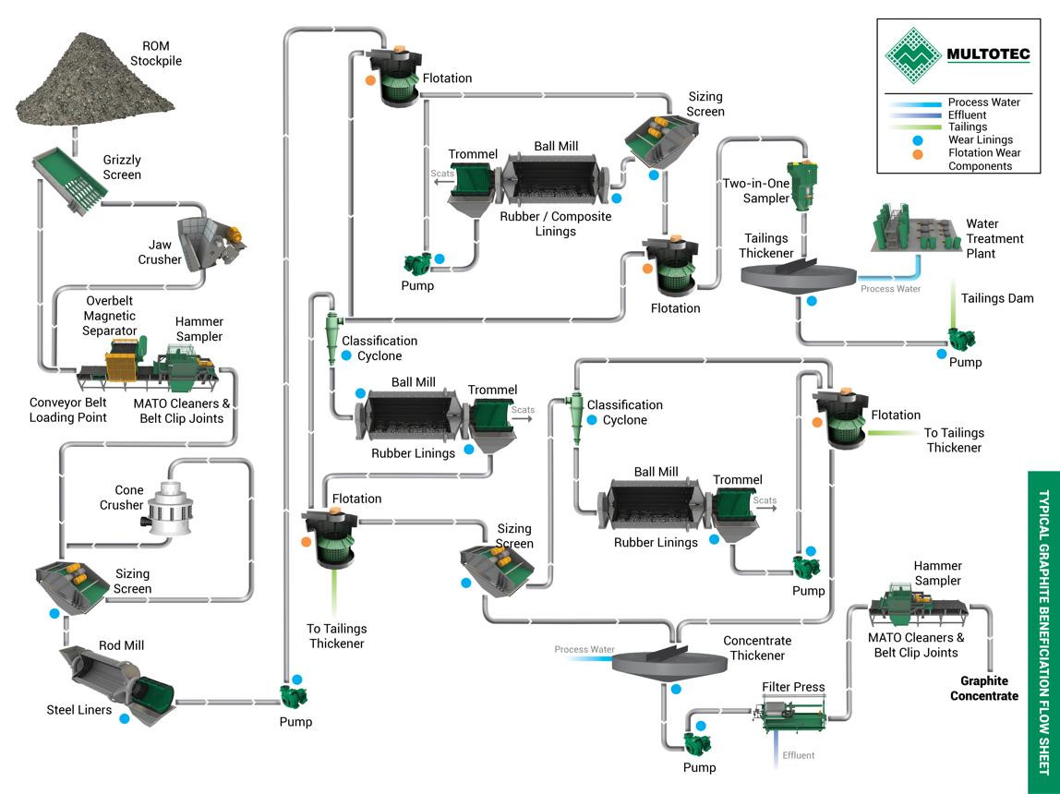
The Project

From Run-of-Mine Graphite to Value-Added Manufacturing
Developing an integrated graphite processing and manufacturing platform in Mpwapwa District, Dodoma Region, Tanzania.
Graphite Industries Limited is developing a proposal for an integrated graphite processing facility intended to evaluate opportunities across the graphite value chain, from mineral feedstock and beneficiation to higher-value industrial graphite products.
Our development strategy combines technical evaluation, responsible industrial planning, market development, and strategic partnerships to identify a commercially viable route for graphite value addition in Tanzania.

Our Integrated Development Vision
Feedstock Evaluation
Assess suitable graphite-bearing ore sources, mineral characteristics, supply arrangements, and resource development opportunities.
Graphite Beneficiation
Evaluate appropriate crushing, grinding, flotation, concentrate upgrading, and product preparation technologies.
Value-Added Manufacturing
Investigate the production of selected industrial graphite products, including micronised and expandable graphite, subject to technical and commercial validation.
Advanced Product Opportunities
Assess higher-specification graphite manufacturing opportunities where feedstock properties, technology, customer qualification, and investment economics justify further development.

Our Investment Approach
We intend to advance the project through defined technical and commercial milestones. Plant capacity, process configuration, product mix, capital requirements, and implementation timing will be established through appropriate studies rather than assumed in advance.

Partnership Opportunities
We welcome discussions with qualified investors, graphite processing technology providers, engineering contractors, mineral supply partners, development finance institutions, and prospective product buyers.
Explore the Project | Investment and Partnership Enquiries

Project Status
The proposed facility is at the development and investor-attraction stage. Feedstock sources, processing capacity, product specifications, engineering requirements, financing, and implementation plans remain subject to further evaluation.
Location: Mpwapwa District, Dodoma Region, Tanzania
Company: Graphite Industries Limited
All proposed activities and products remain subject to technical feasibility, commercial assessment, applicable licences, environmental approvals, and financing.

10. Recommended visual and technical specification
Branding
Graphite black, deep navy, mineral green, and restrained metallic accents. Use a dedicated logo and corporate identity for Graphite Industries Limited.
Platform
Responsive WordPress website or custom-developed website, with secure hosting, HTTPS, backups, and mobile optimisation.
Investor resources
A downloadable corporate project brief, project development roadmap, verified technical summaries, and a protected channel for confidential enquiries.
Search visibility and enquiries
Search-engine optimisation, business enquiry forms, corporate email integration, and analytics with appropriate privacy controls.

11. Immediate implementation plan
- Confirm the company identity: registered company name or proposed name, corporate registration details where applicable, approved logo, and authorised contact information.

- Prepare the technical project brief: identify possible feedstock sources, the status of any mineral rights, available samples and reports, and the intended manufacturing products.

- Commission preliminary technical and market work: establish a credible basis for selecting the process route, target product specifications, and eventual plant capacity.

- Build the corporate website: develop the homepage, project, products, investment, sustainability, and contact pages using the proposed identity and copy.
Prepare investor materials: align the website, project brief, technical programme, development milestones, and funding proposition
  - Project Company: Graphite Industries Limited
  - Project: Integrated graphite processing and manufacturing facility
  - Project Location: Mpwapwa District, Dodoma Region, Tanzania
  - Business model: Run-of-mine graphite feedstock evaluation, beneficiation, and multiple value-added graphite products
  - Development stage: Development and investor attraction
  - Partnership Opportunities: We welcome discussions with qualified investors, graphite processing technology providers, engineering contractors, mineral supply partners, development finance institutions, and prospective product buyers.
  - Plant capacity and investment: To be determined by feasibility studies
Logistic
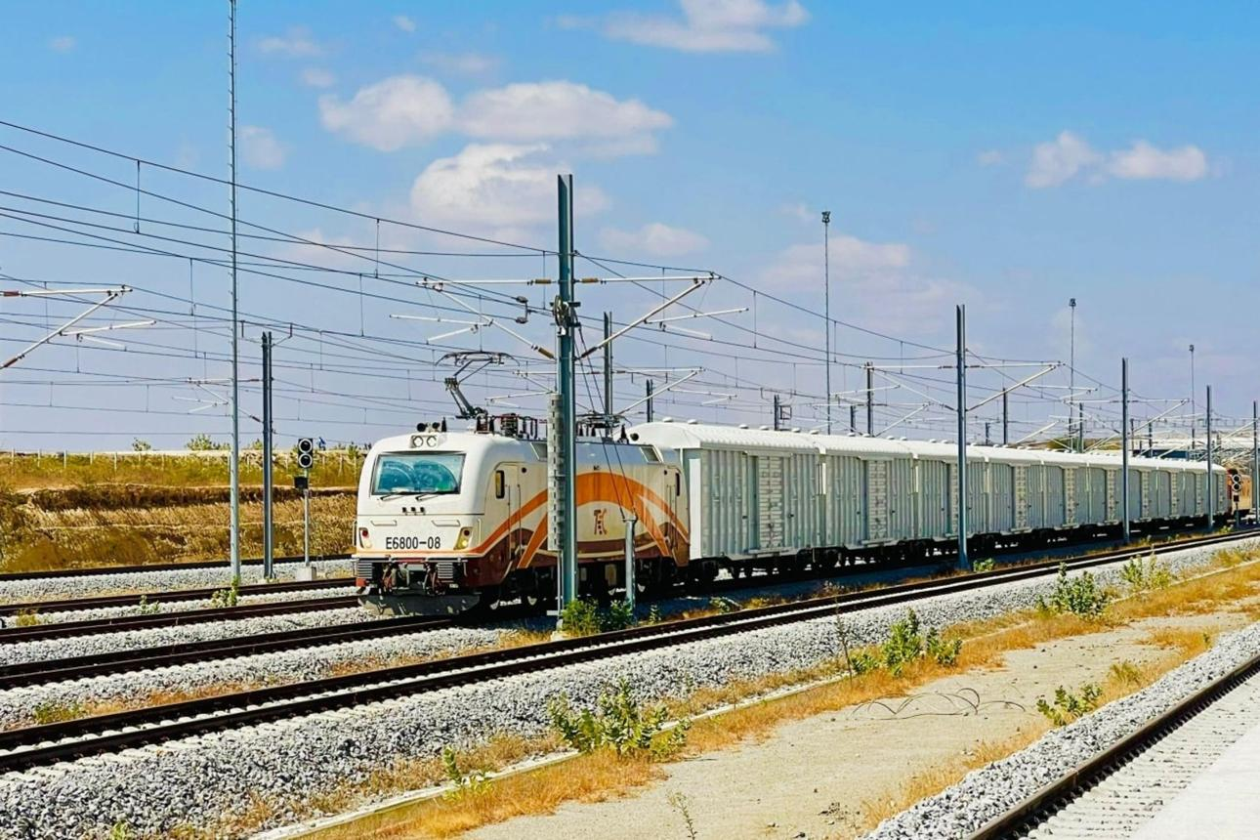

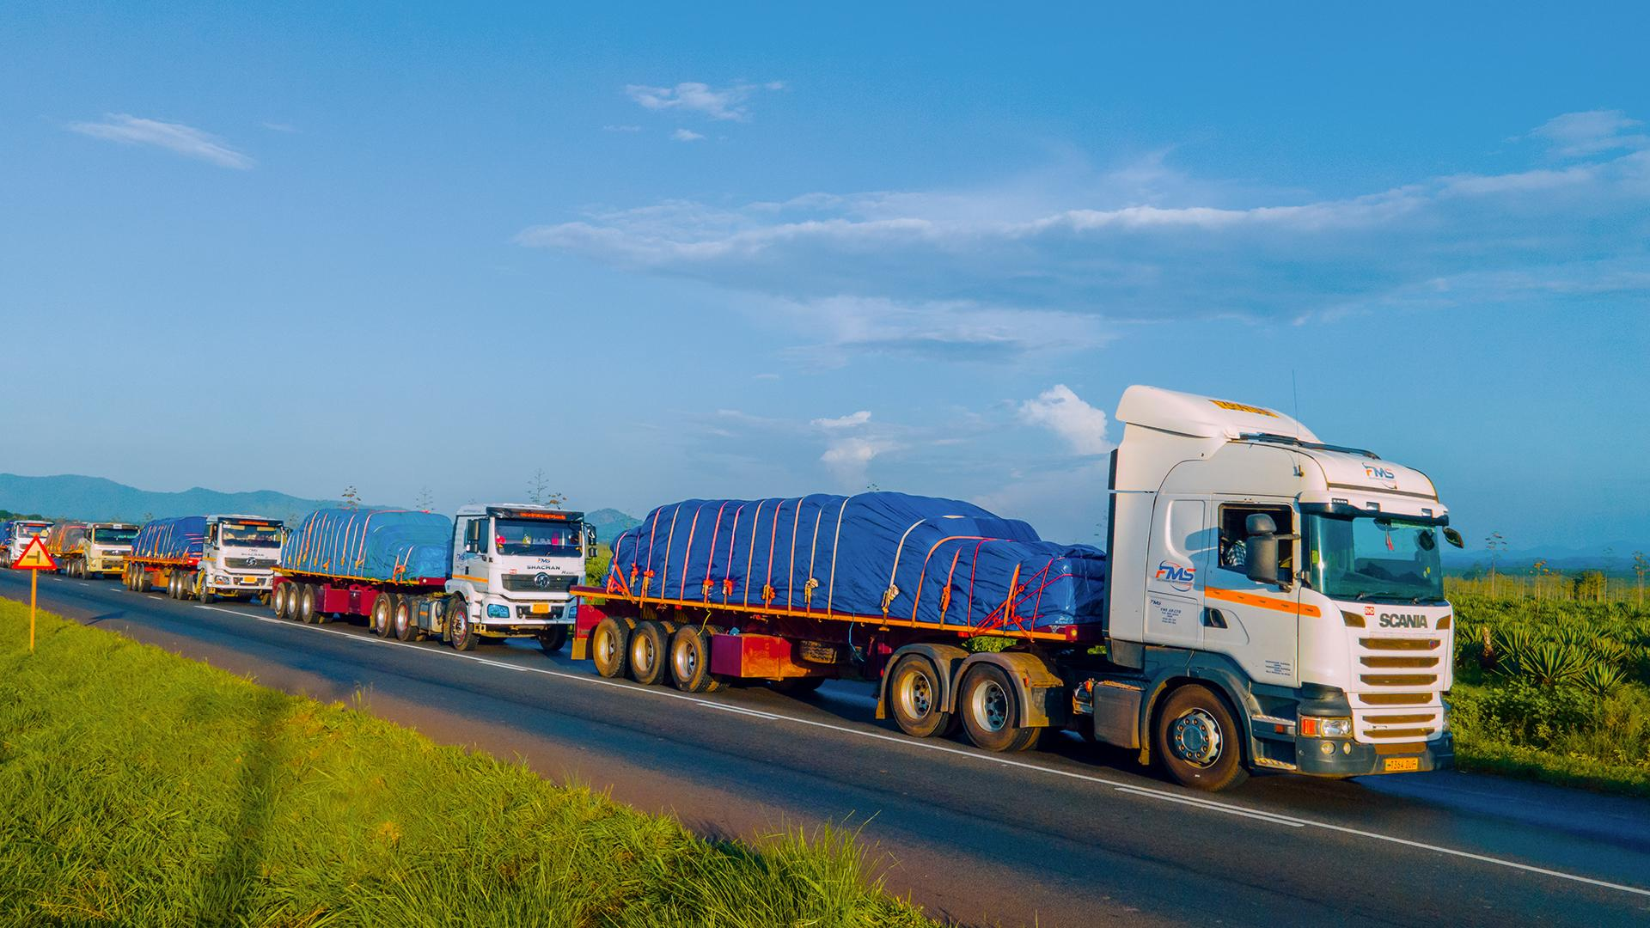

Additional pages that would improve the website
Page or feature | Purpose
Leadership & Governance | Introduce verified directors and management, corporate governance and accountability.
Project Development Roadmap | Explain the stages from investigations and testing to engineering, approvals, financing and construction.
Products & Applications | Explain potential graphite products and their industrial applications without promising unverified grades.
Markets  Logistics & Transport | Describe potential regional and international market access and transport options, subject to assessment.
Sustainability & ESG | Cover environmental management, water, waste, rehabilitation, community engagement, worker safety and gender inclusion.
Technology & Partnerships | Invite mineral laboratories, engineering companies, equipment manufacturers and strategic partners to engage.
Investor Relations | Provide the corporate project brief, verified company documents and an investor enquiry channel.
News & Project Updates | Publish dated, factual progress updates and company announcements.
Contact & Enquiries | Provide verified contact details and a secure, functioning enquiry form.

3. Recommended visual standards

GRAPHITE INDUSTRIES LIMITED — brand system

Graphite Charcoal
#292D30
Headers, footer and primary text

Mineral Green
#16803C
Accents, links and calls to action

Mineral Grey
#F2F4F3
Section backgrounds and cards

White
#FFFFFF
Clean space and readable layouts
Design rules
- Use the approved oval logo consistently.
- Keep navigation simple and mobile-friendly.
- Use authentic project photographs only when available; label illustrative imagery.
- Avoid excessive animations, crowded pages and unsupported technical claims.
- Use readable fonts, strong contrast and accessible image descriptions.

4. Features expected of a professional website
The following should be addressed before launch.
- Mobile responsiveness: pages must work properly on Android phones, tablets and desktop computers.
- Security: HTTPS, secure hosting, software updates and protection against spam and malicious form submissions.
- Working contact forms: messages should reach an authorised company email address, with appropriate spam protection and privacy safeguards.
- Search engine optimisation: descriptive page titles, search-friendly URLs, metadata, sitemap and appropriate indexing controls.
- Performance: compressed images, efficient scripts and fast page loading, including on slower connections.
- Corporate downloads: properly formatted PDF documents with consistent branding and revision dates.
- Legal and privacy information: suitable privacy notice, copyright statement and accurate corporate disclosures.
- Analytics and maintenance: measure website traffic appropriately, check broken links and keep content current.
What an international-standard corporate website should include
1. Professional homepage
- Approved logo and consistent brand colours.
- Clear headline: Advancing Graphite. Creating Industrial Value.
- Concise project introduction and location.
- Prominent links for investors, buyers and technology partners.
- A clear notice that the project is proposed.

- Strong corporate identity
- Explain the company's purpose, vision, mission, objectives,
- development strategy and commitment to responsible mineral value addition.
- Include verified company registration information when available.
- Technical project presentation
- Describe the proposed Mpwapwa project,
- the planned 2,000-tonne-per-day ROM feed capacity,
- development stages,
- proposed studies and infrastructure assessments.
- Distinguish planning assumptions from completed studies and verified facts.

- Commercial and partnership opportunities
- Give prospective buyers, investors, equipment suppliers and engineering companies clear ways to express interest.
- Do not imply confirmed customers, product specifications or commercial contracts unless verified.

Additional pages that would improve the website
Page or feature | Purpose
Leadership & Governance | Introduce verified directors and management, corporate governance and accountability.
Project Development Roadmap | Explain the stages from investigations and testing to engineering, approvals, financing and construction.
Products & Applications | Explain potential graphite products and their industrial applications without promising unverified grades.
Markets & Logistics | Describe potential regional and international market access and transport options, subject to assessment.
Sustainability & ESG | Cover environmental management, water, waste, rehabilitation, community engagement, worker safety and gender inclusion.
Technology & Partnerships | Invite mineral laboratories, engineering companies, equipment manufacturers and strategic partners to engage.
Investor Relations | Provide the corporate project brief, verified company documents and an investor enquiry channel.
News & Project Updates | Publish dated, factual progress updates and company announcements.
Contact & Enquiries | Provide verified contact details and a secure, functioning enquiry form.

ENVIRONMENTAL, SOCIAL AND GOVERNANCE (ESG)

Responsible Graphite Mining and Processing
GRAPHITE INDUSTRIES LIMITED recognises that responsible mineral development requires careful consideration of environmental protection, social well-being and sound corporate governance.
Our intended ESG approach will guide the planning and potential development of the proposed graphite mining and processing project in Mpwapwa District, Dodoma Region, Tanzania. We aim to integrate responsible resource management, inclusive stakeholder engagement, workplace safety and accountable business practices into project planning and future operations.
Our ESG priorities will be developed in line with applicable Tanzanian laws and regulatory requirements, project-specific assessments and relevant industry practices.

1. Environmental Responsibility
The company intends to incorporate environmental considerations throughout project planning, mining, processing and future site rehabilitation.
Key areas of focus include:
- Environmental assessment: Identify potential environmental impacts and establish appropriate management measures through the applicable assessment and approval processes.
- Water management: Assess water availability, monitor consumption and investigate opportunities for water recovery and reuse in mineral processing.
- Energy efficiency: Evaluate energy requirements and opportunities to improve efficiency in mining, crushing, grinding and processing operations.
- Waste and tailings management: Develop appropriate arrangements for waste rock, process residues, tailings and other operational waste.
- Land management and rehabilitation: Plan for responsible land disturbance, erosion control, progressive rehabilitation where practicable and eventual site closure.
- Biodiversity and pollution prevention: Assess relevant ecological sensitivities and implement appropriate controls for dust, noise, emissions and potential contamination.
- Climate considerations: Evaluate climate-related risks, resource efficiency and opportunities to reduce avoidable greenhouse gas emissions.
Environmental management measures will be defined through project-specific investigations, environmental assessments and approved management plans.

2. Social Responsibility
GRAPHITE INDUSTRIES LIMITED intends to promote constructive relationships with employees, neighbouring communities, suppliers and other stakeholders.
Our social priorities include:
- Occupational health and safety: Develop systems intended to protect workers, contractors and visitors from workplace hazards.
- Community engagement: Encourage transparent communication and appropriate consultation with affected communities and relevant stakeholders.
- Gender inclusion and equal opportunity: Promote fair employment practices, skills development and opportunities for women's participation in technical, operational, professional and leadership roles.
- Local participation: Assess opportunities for Tanzanian employment, training, supplier development and local procurement, subject to project requirements and applicable regulations.
- Labour standards: Work towards fair working conditions, respect for workers' rights and a workplace free from discrimination, harassment and intimidation.
- Grievance management: Establish appropriate channels through which employees and community members can raise concerns and seek responses.
- Skills development: Evaluate opportunities for technical training, knowledge transfer and workforce development as the project advances.
The company intends to refine these priorities through stakeholder engagement and project-specific social assessments.

3. Corporate Governance
Sound governance will be important to the company's development, stakeholder confidence and long-term business sustainability.
Governance priorities are intended to include:
- Board oversight and accountability: Establish clear responsibilities for strategic direction, management oversight and risk supervision.
- Legal and regulatory compliance: Conduct project activities in accordance with applicable laws, permits, licences and regulatory obligations.
- Ethical business conduct: Promote integrity, transparency, fair dealing and responsible commercial relationships.
- Risk management: Identify and assess technical, operational, financial, environmental, social and regulatory risks.
- Anti-bribery and corruption: Develop appropriate standards and controls to prevent bribery, corruption, fraud and improper business conduct.
- Procurement integrity: Promote transparent supplier evaluation and responsible procurement practices.
- Information and reporting: Maintain appropriate records and communicate verified company and project information accurately.
- Business partner due diligence: Evaluate prospective suppliers, contractors, customers and strategic partners according to relevant legal, ethical and commercial considerations.
Governance policies and reporting arrangements will be developed in line with the company's organisational structure and applicable requirements.

4. ESG Integration Across the Project Lifecycle
ESG considerations are intended to form part of the project's development process, from early investigations through feasibility assessment, implementation and potential future operations.
During project development, the company expects to assess environmental and social risks, identify relevant mitigation measures, determine applicable approval requirements and establish appropriate monitoring arrangements.
As the project progresses, ESG priorities and performance indicators will be refined to reflect verified site conditions, regulatory obligations, operational requirements and stakeholder expectations.

5. Monitoring, Accountability and Continuous Improvement
GRAPHITE INDUSTRIES LIMITED intends to develop a practical approach to monitoring relevant environmental, social and governance performance as its organisational and project capabilities mature.
Potential indicators may include water use, energy consumption, waste management, workplace safety, employee training, gender representation, local procurement and stakeholder grievance resolution.
Targets and reporting arrangements will be established when suitable baselines, responsibilities and monitoring systems are available. The company will communicate ESG progress based on verified information and avoid presenting proposed commitments as completed achievements.

Our ESG Commitment
GRAPHITE INDUSTRIES LIMITED aims to pursue responsible graphite resource development by integrating environmental stewardship, inclusive social practices and accountable governance into its proposed mining and processing activities.
Our objective is to build a foundation for responsible industrial development, meaningful stakeholder relationships and long-term value creation in Tanzania.
Recommended ESG page design
    - E — Environmental
Water stewardship, energy efficiency, pollution prevention, waste management and rehabilitation.
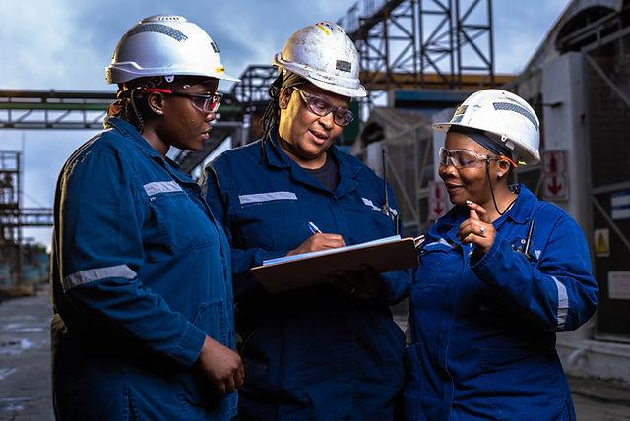
    - S — Social
Worker safety, gender inclusion, local employment, skills development and community engagement.

    - G — Governance
Accountability, legal compliance, ethical conduct, risk management and transparent reporting.

